**Objective Questions:**

1. What is the distribution of account balances across different regions?

Ans: - The answer is provided in the SQL file. The code used and the result are given below for reference:

select c.Geography,

count(c.customerid) as number_of_customers,

round(avg(b.balance),2) as average_balance,

round(sum(b.Balance),2)as total_account_balance

from customerinfo c

inner join bankchurn b

on c.customerid=b.CustomerId

group by 1;

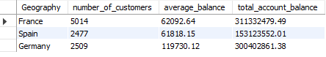

1. Identify the top 5 customers with the highest Estimated Salary in the last quarter of the year. (SQL)

Ans: - The answer is provided in the SQL file. The code used and the result are given below for reference:

select CustomerId,Surname, bankdoj,EstimatedSalary

from customerinfo

where extract(month from bankdoj) in (10,11,12)

order by EstimatedSalary desc

limit 5;

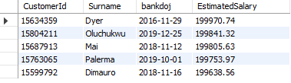

1. Calculate the average number of products used by customers who have a credit card. (SQL)

Ans: - The answer is provided in the SQL file. The code used and the result are given below for reference:

select avg(numofproducts) as avg_of_products

from bankchurn

where HasCreditCard = 1;



1. Determine the churn rate by gender for the most recent year in the dataset.

Ans: - The answer is provided in the SQL file. The code used and the result are given below for reference:

select c.Gender,

count(b.customerid) as churncustomers

from bankchurn b

inner join customerinfo c

on c.CustomerId=b.CustomerId

where year(c.BankDOJ) = 2019 and b.ExitCustomer = 'Exit'

group by 1;



1. Compare the average credit score of customers who have exited and those who remain. (SQL)

Ans: - The answer is provided in the SQL file. The code used and the result are given below for reference:

SELECT Exited,

AVG(CreditScore) AS avg_credit_score

FROM bankchurn

GROUP BY Exited;

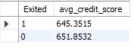

----------------------------------------------------------------------------------------------

# or we can also solve the same using CTE (Common table expression)

WITH cte1 AS

(SELECT 'Exit' AS status,

AVG(CreditScore) AS avg_credit_score

FROM bankchurn

WHERE ExitCustomer = 'Exit'),

cte2 AS

(SELECT 'Retain' AS status,

AVG(CreditScore) AS avg_credit_score

FROM bankchurn

WHERE ExitCustomer = 'Retain')

SELECT

cte1.avg_credit_score AS avg_credit_score_of_exit_customers,

cte2.avg_credit_score AS avg_credit_score_of_retain_customers,

(cte2.avg_credit_score-cte1.avg_credit_score) AS compared_avg

FROM cte1 inner JOIN cte2 on 1=1;



1. Which gender has a higher average estimated salary, and how does it relate to the number of active accounts? (SQL)

Ans: - The answer is provided in the SQL file. The code used and the result are given below for reference:

WITH CTE1 AS

(SELECT c.Gender,AVG(c.EstimatedSalary) AS AvgSalary,

SUM(CASE WHEN b.ActiveCustomer = 'Active Member' THEN 1 ELSE 0 END) AS ActiveAccounts

FROM customerinfo c

inner join bankchurn b ON c.CustomerId = b.CustomerId

GROUP BY c.Gender)

SELECT Gender,ROUND(AvgSalary, 2) AS AvgSalary,ActiveAccounts

FROM CTE1 order by AvgSalary desc limit 1;



1. Segment the customers based on their credit score and identify the segment with the highest exit rate. (SQL)

Ans: - The answer is provided in the SQL file. The code used and the result are given below for reference:

WITH CreditScoreSegments AS (SELECT

CASE WHEN CreditScore BETWEEN 800 AND 850 THEN 'Excellent'

WHEN CreditScore BETWEEN 740 AND 799 THEN 'Very Good'

WHEN CreditScore BETWEEN 670 AND 739 THEN 'Good'

WHEN CreditScore BETWEEN 580 AND 669 THEN 'Fair'

WHEN CreditScore BETWEEN 300 AND 579 THEN 'Poor'

ELSE 'Unknown'END AS CreditScoreSegment,

COUNT(*) AS TotalCustomers,

SUM(Exited) AS ChurnedCustomers,

100 * SUM(Exited) / COUNT(*) AS ExitRate FROM Bankchurn

GROUP BY CreditScoreSegment)

SELECT CreditScoreSegment,TotalCustomers,ChurnedCustomers,ExitRate

FROM CreditScoreSegments

ORDER BY ExitRate DESC

LIMIT 1;



1. Find out which geographic region has the highest number of active customers with a tenure greater than 5 years. (SQL)

Ans: - The answer is provided in the SQL file. The code used and the result are given below for reference:

select c.Geography,

count(b.customerid) as number_of_customers

from customerinfo c

inner join bankchurn b

on c.CustomerId=b.CustomerId

where b.IsActiveMember =1 and Tenure > 5 group by 1 order by 2 desc

limit 1;



1. What is the impact of having a credit card on customer churn, based on the available data?

Ans: - The answer is provided in the SQL file. The code used and the result are given below for reference:

Select

CreditCard,

SUM(Case When ActiveCustomer = 'Active Member' Then 1 Else 0 END) AS ActiveCustomers,

SUM(Case When ActiveCustomer = 'Inactive Member' Then 1 Else 0 END) AS InactiveCustomers,

SUM(Case When ExitCustomer = 'Exit' Then 1 ELSE 0 END) AS ExitCustomers,

SUM(Case WHen ExitCustomer = 'Retain' Then 1 Else 0 END) AS RetainedCustomers,

COUNT(customerID) AS OverallTotalCustomers

From bankchurn

Group by CreditCard;



1. For customers who have exited, what is the most common number of products they have used?

Ans: - The answer is provided in the SQL file. The code used and the result are given below for reference:

Select

NumofProducts,

COUNT(CustomerID) AS NumOfCustomers

From Bankchurn

Where ExitCustomer = 'Exit'

Group by NumofProducts

Order by NumofCustomers DESC

LIMIT 1;



1. Examine the trend of customers joining over time and identify any seasonal patterns (yearly or monthly). Prepare the data through SQL and then visualize it.

Ans: - The answer is provided in the SQL file. The code used and the result are given below for reference:

--------------- Yearly Trend

Select

YEAR(BankDOJ) AS JoiningYear,

COUNT(CustomerID) AS NumofCustomers

From customerINFO

Group by JoiningYear

Order by joiningyear;

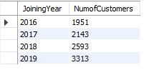

-------------- Monthly Trend

Select

YEAR(BankDOJ) AS JoiningYear,

Month(BankDOJ) AS JoiningMonth,

COUNT(customerID) AS NumOfCustomers

From customerInfo

Group by JoiningYear, JoiningMonth

Order by JoiningYear, JoiningMonth;

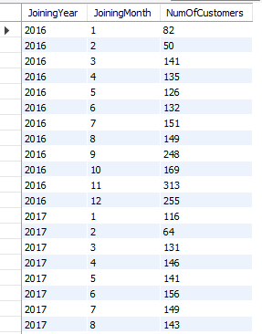

1. Analyze the relationship between the number of products and the account balance for customers who have exited.

Ans: - The answer is provided in the SQL file. The code used and the result are given below for reference:

Select

NumofProducts,

round(AVG(Balance),2) AS AvgBalance,

MIN(Balance) AS MinBalance,

MAX(Balance) AS MaxBalance,

round(SUM(Balance),2) AS TotalBalance

From BankChurn

WHere ExitCustomer = 'Exit'

Group by NumofProducts;

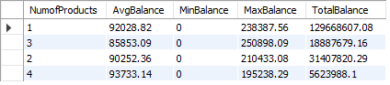

1. Identify any potential outliers in terms of balance among customers who have remained with the bank.

Ans: - The answer is provided in the SQL file. The code used and the result are given below for reference:

Select

customerID,

Exitcustomer,

Balance

From Bankchurn

Where ExitCustomer LIKE 'Retain'

Order by Balance DESC;

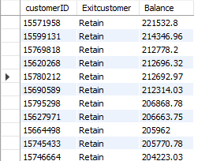

1. How many different tables are given in the dataset, out of these tables which table only consists of categorical variables?

Ans: - We Have Seven Different tables i.e., ActiveCustomer, Bank_Churn,CreditCard,CustomerInfo,ExitCustomer,Gender,Geography.Tables with Categorical Variables:

* CustomerInfo:Contains categorical variables like Surname.
* ExitCustomer: Contains categorical variables like Exit Category(Exit ,Retain).
* Gender: Contains categorical variables like Gender Category (Male,Female).
* Geography:Contains categorical variables like Geography Location (France, Spain,Germany).
* ActiveCustomer: Contains categorical variables like Active Category (Active Member , Inactive Member).
* CreditCard: Contains categorical variables like Category (Credit-card holder , Non-Credit card holder)

1. Using SQL, write a query to find out the gender-wise average income of males and females in each geography id. Also, rank the gender according to the average value. (SQL)

Ans: - The answer is provided in the SQL file. The code used and the result are given below for reference:

WITH GenderAvgIncome AS

(SELECT Geography,Gender,

AVG(EstimatedSalary) AS AvgIncome

FROM customerinfo GROUP BY 1,2),

RankedGenderAvgIncome AS

(SELECT Geography, Gender,AvgIncome,

RANK() OVER (PARTITION BY Geography ORDER BY AvgIncome DESC) AS Ranked

FROM GenderAvgIncome)

SELECT Geography,Gender,round(AvgIncome ,2)as AvgIncome,Ranked

FROM RankedGenderAvgIncome

ORDER BY Geography, Ranked;

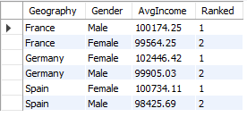

1. Using SQL, write a query to find out the average tenure of the people who have exited in each age bracket (18-30, 30-50, 50+).

Ans: - The answer is provided in the SQL file. The code used and the result are given below for reference:

Select Case

When AGE Between 18 And 30 Then '18-30'

When AGE Between 31 and 50 Then '31-50'

ELSE '50+' END AS AgeBracket,

ROUND(AVG(tenure),2) AS AverageTenure

From customerinfo c

JOIN Bankchurn b ON

c.customerID = b.customerID

Where ExitCustomer = 'Exit'

Group by AgeBracket;

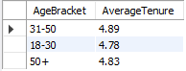

1. Is there any direct correlation between salary and the balance of the customers? And is it different for people who have exited or not?

Ans: - These SQL queries calculate the correlation coefficient between salary and balance for all customers, as well as for churned and non-churned customers separately.

* For all customers, there is a weak positive correlation coefficient (0.0128), indicating a slight positive relationship between salary and balance.
* However, when analyzing churned and non-churned customers separately, the correlation coefficients are close to zero (-0.0125 for churned customers and 0.0172 for non-churned customers), suggesting almost no linear relationship between salary and balance within these subsets.
* In summary, while a slight positive correlation exists between salary and balance for the overall customer base, this relationship loses significance when considering churned and non-churned customers independently.

The answer is provided in the SQL file. The code used and the result are given below for reference:

-----------------------------Correlation Coefficient for All Customers

SELECT

ROUND((COUNT(*) * SUM(EstimatedSalary * Balance) - SUM(EstimatedSalary) * SUM(Balance)) /

SQRT((COUNT(*) * SUM(EstimatedSalary * EstimatedSalary) - POW(SUM(EstimatedSalary), 2)) *

(COUNT(*) * SUM(Balance * Balance) - POW(SUM(Balance), 2))),4) AS Correlation_AllCustomers

FROM bankchurn ch

join customerinfo c on c.CustomerId=ch.CustomerId;

----------------------------Correlation Coefficient for Exited customer

SELECT

ROUND((COUNT(*) * SUM(EstimatedSalary * Balance) - SUM(EstimatedSalary) * SUM(Balance)) /

SQRT((COUNT(*) * SUM(EstimatedSalary * EstimatedSalary) - POW(SUM(EstimatedSalary), 2)) *

(COUNT(*) * SUM(Balance * Balance) - POW(SUM(Balance), 2))),4) AS Correlation_churned_Customers

FROM bankchurn ch

join customerinfo c on c.CustomerId=ch.CustomerId

WHERE Exited = 1;

-----------------------Correlation Coefficient for not Retained customer

SELECT

ROUND((COUNT(*) * SUM(EstimatedSalary * Balance) - SUM(EstimatedSalary) * SUM(Balance)) /

SQRT((COUNT(*) * SUM(EstimatedSalary * EstimatedSalary) - POW(SUM(EstimatedSalary), 2)) *

(COUNT(*) * SUM(Balance * Balance) - POW(SUM(Balance), 2))),4) AS Correlation_not_churned_Customers

FROM bankchurn ch

join customerinfo c on c.CustomerId=ch.CustomerId

WHERE Exited = 0;

  

1. Is there any correlation between the salary and the Credit score of customers?

Ans: - This SQL query calculates the correlation coefficient between customers' salaries and credit scores. The resulting coefficient of -0.0014 indicates a very weak correlation between these two variables. In summary, there is minimal evidence to suggest any significant relationship between customers' salaries and credit scores.

The answer is provided in the SQL file. The code used and the result are given below for reference:

SELECT ROUND((COUNT(*) * SUM(EstimatedSalary * CreditScore) - SUM(EstimatedSalary) * SUM(CreditScore)) /

SQRT((COUNT(*) * SUM(EstimatedSalary * EstimatedSalary) - POW(SUM(EstimatedSalary), 2)) *

(COUNT(*) * SUM(CreditScore * CreditScore) - POW(SUM(CreditScore), 2))),4) AS Correlation_Salary_CreditScore

FROM customerinfo c join bankchurn ch on c.customerid=ch.CustomerId;



1. Rank each bucket of credit score as per the number of customers who have churned the bank.

Ans: - The answer is provided in the SQL file. The code used and the result are given below for reference:

SELECT CASE

WHEN CreditScore BETWEEN 800 AND 850 THEN 'Excellent'

WHEN CreditScore BETWEEN 740 AND 799 THEN 'Very Good'

WHEN CreditScore BETWEEN 670 AND 739 THEN 'Good'

WHEN CreditScore BETWEEN 580 AND 669 THEN 'Fair'

WHEN CreditScore BETWEEN 300 AND 579 THEN 'Poor'

ELSE 'Unknown'END AS CreditScoreCaregory, COUNT(*) AS NumChurnedCustomers,

DENSE_RANK() OVER (ORDER BY COUNT(*) DESC) AS CreditRank

FROM Bankchurn

WHERE ExitCustomer = 'Exit'

GROUP BY CreditScoreCaregory

ORDER BY CreditRank;

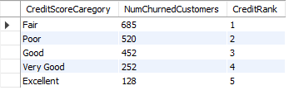

1. According to the age buckets find the number of customers who have a credit card. Also retrieve those buckets that have lesser than average number of credit cards per bucket.

Ans: - The answer is provided in the SQL file. The code used and the result are given below for reference:

SELECT CASE

WHEN Age BETWEEN 18 AND 30 THEN '18-30'

WHEN Age BETWEEN 30 AND 50 THEN '30-50'

WHEN Age >= 50 THEN '50+' ELSE 'Unknown' END AS AgeBucket,

COUNT(*) AS NumofCustomers FROM customerinfo c

JOIN bankchurn bc on c.CustomerId=bc.CustomerId

WHERE HasCreditCard=1

group by AgeBucket;

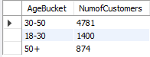

--------------------------------------------------------------------

WITH CreditCardCounts AS

(SELECT CASE

WHEN Age BETWEEN 18 AND 30 THEN '18-30'

WHEN Age BETWEEN 31 AND 50 THEN '31-50'

WHEN Age >= 51 THEN '50+'

ELSE 'Unknown'END AS AgeBucket,

SUM(HasCreditCard) AS CreditCardCount,

COUNT(*) AS TotalCustomers

FROM customerinfo c join bankchurn bc on c.CustomerId=bc.CustomerId

GROUP BY AgeBucket),

AverageCreditCards AS

(SELECT AVG(CreditCardCount) AS AvgCreditCards

FROM CreditCardCounts)

SELECT AgeBucket,CreditCardCount,TotalCustomers

FROM CreditCardCounts

WHERE CreditCardCount < (SELECT AvgCreditCards FROM AverageCreditCards);

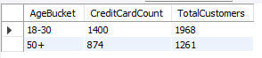

1. Rank the Locations as per the number of people who have churned the bank and average balance of the customers.

Ans: - The answer is provided in the SQL file. The code used and the result are given below for reference:

WITH LocationChurnStats AS

(SELECT Geography,

COUNT(*) AS NumChurnedCustomers,

ROUND(AVG(Balance),2) AS AvgBalance

FROM customerinfo c

JOIN Bankchurn bc ON c.CustomerId = bc.CustomerId

WHERE Exited = 1 GROUP BY Geography)

SELECT Geography, NumChurnedCustomers, AvgBalance,

RANK() OVER (ORDER BY NumChurnedCustomers DESC, AvgBalance DESC) AS LocationRank

FROM LocationChurnStats

ORDER BY LocationRank;

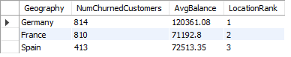

1. As we can see that the “CustomerInfo” table has the CustomerID and Surname, now if we have to join it with a table where the primary key is also a combination of CustomerID and Surname, come up with a column where the format is “CustomerID_Surname”.

Ans: - To create a new column named "CustomerID_Surname" as part of the result set from a join between the "CustomerInfo" table and another table, where the primary key is a combination of CustomerID and Surname, follow these steps:

1. **Ensure Data Types:**
   * Confirm that the CustomerID in "CustomerInfo" is of a character data type or can be converted to one. Depending on your database system, you might not need the CONVERT function.
2. **Perform Join on Individual Columns:**
   * Execute a join between the "CustomerInfo" table and the other table using separate columns for CustomerID and Surname, rather than a combined primary key.
3. **Create the New Column:**
   * In the SELECT clause of your query, use the CONCAT function (or an equivalent function in your database system) to concatenate the CustomerID and Surname columns from "CustomerInfo," separated by an underscore ("_").
4. Without using “Join”, can we get the “ExitCategory” from ExitCustomers table to Bank_Churn table? If yes do this using SQL.

Ans: - Yes, we can retrieve the “ExitCategory” from the ExitCustomers table using a subquery in SQL. However, I have already performed this step in Excel while cleaning the data and given below is the query for the same.

SELECT *,

(SELECT e.ExitCategory

FROM ExitCustomers e

WHERE e.ExitID = b.Exited) AS ExitCategory

FROM BankChurn b;

1. Were there any missing values in the data, using which tool did you replace them and what are the ways to handle them?

Ans: - In this section, we address the data cleaning steps undertaken to prepare the dataset for analysis. While our dataset does not contain any missing values, several modifications were made to ensure data quality and consistency:

1. **Removal of Special Characters:**
   * Special characters present in the dataset were removed to standardize the data and avoid potential issues during analysis.
2. **Corrections in Categorical Columns:**
   * Adjustments were made to the "ActiveCategory" and "ExitCategory" columns. Some rows indicated that customers who had exited the bank were still marked as active, which is logically inconsistent. These errors were corrected to accurately reflect customer statuses.
3. **Format Adjustment for Date Column:**
   * The format of the date column was originally in text format. Using a query, this column was updated to a proper date format to facilitate accurate analysis.

These changes were essential to eliminate errors and ensure the dataset's reliability for subsequent analysis.

1. Write the query to get the customer IDs, their last name, and whether they are active or not for the customers whose surname ends with “on”.

Ans: - The answer is provided in the SQL file. The code used and the result are given below for reference:

select c.CustomerId,c.Surname,b.ActiveCustomer

from customerinfo c

inner join bankchurn b

on c.CustomerId=b.CustomerId

where c.Surname like "%on";

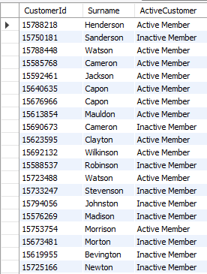

1. Can you observe any data disrupency in the Customer’s data? As a hint it’s present in the IsActiveMember and Exited columns. One more point to consider is that the data in the Exited Column is absolutely correct and accurate.

Ans: - A data discrepancy was observed in the customer data, specifically in the "IsActiveMember" and "Exited" columns. There were instances where customers who had exited were still marked as active members. Upon examination, 735 rows were found where exited customers were incorrectly labeled as active. To rectify this inconsistency, all instances of exited customers were updated to reflect inactive membership

UPDATE Bankchurn

SET IsActiveMember = 0

WHERE Exited = 1 AND IsActiveMember = 1;

**Subjective Question:**

1. Customer Behavior Analysis: What patterns can be observed in the spending habits of long-term customers compared to new customers, and what might these patterns suggest about customer loyalty?

Ans: - This analysis explores the spending behaviors of new and long-term customers to gain insights into customer loyalty. We have created three charts to highlight trends in average balance, salary segments, and the number of products owned by both groups. Let's dive into the key insights revealed by these charts:

**Average Balance**

The graph indicates that the average balance of new customers is consistently lower than that of long-term customers. This suggests that long-term customers tend to spend more money with the bank over time.

Here’s a more detailed analysis of the graph:

* Y-axis: Displays the average balance.
* X-axis: Displays the months.
* Red Line: Represents new customers.
* Blue Line: Represents long-term customers.

Key observations:

* The average balance for new customers shows no consistent pattern, fluctuating throughout the year.
* In contrast, long-term customers generally exhibit an increasing average balance over time. Their average balance starts lower than that of new customers in January, but surpasses it by March and continues to rise throughout the year.

Overall, the trend suggests that customers tend to spend more money with the bank the longer they remain customers. Several factors could contribute to this:

* Long-term customers may become more familiar with the bank’s products and services, leading them to utilize more products.
* Increased income over time may enable long-term customers to save more money.
* The bank might offer better interest rates or other benefits to long-term customers, incentivizing them to save more.

Understanding these spending habits can help the bank develop targeted marketing campaigns to attract new customers and retain existing ones.

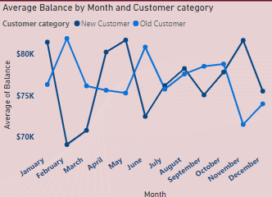

**Location: -**The graph is present in the power bi file in page Additional Analysis 2

**Salary Segment Analysis**

The bar chart illustrates the distribution of new and existing customers across three salary segments: High Salary, Medium Salary, and Low Salary.

* High Salary Segment: This segment has the highest number of customers, totaling 5.1K, with a balanced distribution of 1.7K new customers and 3.4K existing customers. This indicates that the bank has effectively attracted new high-income customers while retaining a substantial portion of its existing high-income clientele. This success may reflect the efficacy of the bank's customer acquisition and retention strategies tailored to high-income individuals.
* Medium Salary Segment: This segment comprises 2.5K customers, where existing customers (1.7K) significantly outnumber new customers (0.8K).
* Low Salary Segment: This segment includes 2.4K customers, with 1.6K existing customers and 0.8K new customers.

The data suggest a robust retention of existing customers in the medium and low salary segments but highlight a relative shortfall in acquiring new customers within these income brackets. This imbalance indicates potential areas for improvement.

The bank's balanced approach in the high salary segment could be attributed to targeted marketing initiatives, attractive product offerings, or superior customer service designed for high-income individuals. Conversely, the disparity observed in the medium and low salary segments underscores the need for the bank to enhance its marketing efforts, introduce new products or services, and intensify outreach and engagement activities to attract new customers in these income brackets.

The significant presence of existing customers in the medium and low salary segments indicates strong customer loyalty within these groups. The bank could capitalize on this loyalty by upselling or cross-selling products tailored to the specific needs of these customers, thereby potentially increasing overall revenue from these segments.

In conclusion, while the bank demonstrates strong performance in the high salary segment, there are clear opportunities for enhancing efforts to attract new customers in the medium and low salary segments, which could facilitate more uniform growth across all income levels.

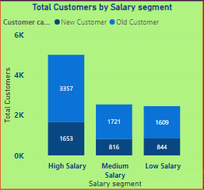

**Location: -**The graph is present in the power bi file in page Additional Analysis 2

Number of Products Analysis

The line chart shows the distribution of new and existing customers based on the number of products they use, ranging from one to four.

Key observations:

* Single Product: Most customers start with a single product, with 3,451 existing and 1,633 new customers.
* Two Products: There is a decline in this category, with 3,022 existing and 1,568 new customers, but it remains the second most common.
* Three Products: The number drops sharply, with only 13 existing and 19 new customers, indicating barriers to adopting multiple products.
* Four Products: Uptake is minimal, with only one existing and one new customer.

The trend shows most customers prefer one or two products. The drop in numbers for three or more products suggests challenges like lack of awareness or insufficient cross-selling strategies. The bank can enhance efforts to promote multiple products through personalized marketing, bundling offers, or loyalty programs.

Leveraging the loyalty of customers with one or two products by encouraging them to try additional offerings tailored to their needs could increase product adoption. Understanding the barriers to multi-product usage through surveys or focus groups can help refine strategies.

In conclusion, while the bank engages customers with one or two products, there are opportunities to improve the adoption of three or more products by addressing barriers and leveraging customer loyalty.

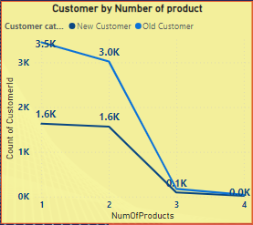

**Location: -**The graph is present in the power bi file in page Additional Analysis 2

1. Product Affinity Study: Which bank products or services are most commonly used together, and how might this influence cross-selling strategies?

Ans: - Customer Behavior Insights and Cross-Selling Strategies

Customer behavior reveals valuable insights into how they use a bank's products. While the line chart analyzed doesn't pinpoint specific product combinations, it highlights a clear trend: most customers use one or two products. Understanding these patterns allows for the development of targeted cross-selling strategies that enhance customer satisfaction and boost revenue.

Commonly Used Products:

* Checking Accounts: Foundation for everyday transactions, providing easy access to funds.
* Debit Cards: Linked to checking accounts for convenient access to funds.
* Savings Accounts: Designed to grow savings, often earning interest.
* Credit Cards: Provide a line of credit for purchases, requiring repayment with interest.
* Loans: Offer tailored financial solutions for specific needs, like mortgages or auto loans.

Cross-Selling Strategies Based on Product Affinity and Usage Trends:

The prevalence of single and double product users suggests opportunities to leverage existing customer relationships. Here’s how:

* Recommend Complementary Products:
  + Checking Account Users: Can be offered debit cards and online banking for easier management.
  + Savings Account Holders: Might be interested in automatic transfers to boost savings or higher-interest options like CDs.
* Personalize Based on Usage:
  + Credit Card Users: Frequent travelers (identifiable through transaction data) could be targeted with travel rewards cards.

Leveraging Digital Platforms:

* Promote Paperless Statements and Bill Autopay: Through online and mobile banking for convenience.
* Offer Investment Options or Financial Tools: Accessible through these platforms to encourage exploration of additional products.

Benefits:

* Increased Revenue: Effective cross-selling expands the customer base for each product, leading to higher overall revenue.
* Enhanced Customer Satisfaction: Customers feel valued when offered products that complement their existing habits and financial goals, building stronger relationships and loyalty.

By analyzing product usage patterns and tailoring recommendations, banks can create a win-win situation that benefits both the institution and its customer



**Location: -**The graph is present in the power bi file in page Additional Analysis 2

The SQL query and its solution are provided in the accompanying SQL file. The result and the query used are detailed below for reference.

Select NumofProducts,

CreditCard,

COUNT(*) AS UsageCount

From bankchurn

Group by NumofProducts, CreditCard

Order by UsageCount DESC;

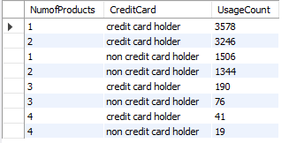

1. Geographic Market Trends: How do economic indicators in different geographic regions correlate with the number of active accounts and customer churn rates?

Ans: - When analyzing the distribution of active customers across different geographic locations, the following insights emerge:

* France: Leads with 52.76% of the total active customer base.
* Spain: Accounts for 25.92% of active customers.
* Germany: Represents 21.29% of the active customer base.

Insights:

* Strong Presence in France: The dominance of active customers in France indicates a robust market presence, making it a key market for both total customers and customer retention. This suggests significant potential for further growth and expansion within the region.
* Steady Performance in Spain: Spain's solid proportion of active customers reflects a stable market environment with consistent customer engagement and retention. This stability provides opportunities for sustained growth and efforts to enhance customer satisfaction and loyalty.
* Opportunities for Growth in Germany: Although Germany has a smaller share of active customers compared to France and Spain, it still presents a significant market opportunity. Strategic initiatives focusing on customer acquisition, retention, and satisfaction can further penetrate the German market and increase active customer participation.

Recommendations:

* Maximize Engagement in France: Leverage the strong presence in France by implementing tailored engagement strategies, personalized offerings, and proactive customer service initiatives to deepen relationships and foster loyalty among French customers.

Sustain Momentum in Spain: Continue nurturing relationships with existing customers in Spain while exploring targeted expansion and market development to capitalize on the stable environment and sustain growth momentum.

Expand Reach in Germany: Invest in targeted marketing campaigns, product innovations, and customer experience enhancements to increase brand awareness, attract new customers, and strengthen market position in Germany, thereby maximizing active customer participation and market share.

By leveraging insights from the analysis of active customers across different geographic locations, the bank can tailor its CRM strategies to effectively address the unique dynamics and opportunities in each market, driving sustainable growth and competitive advantage.

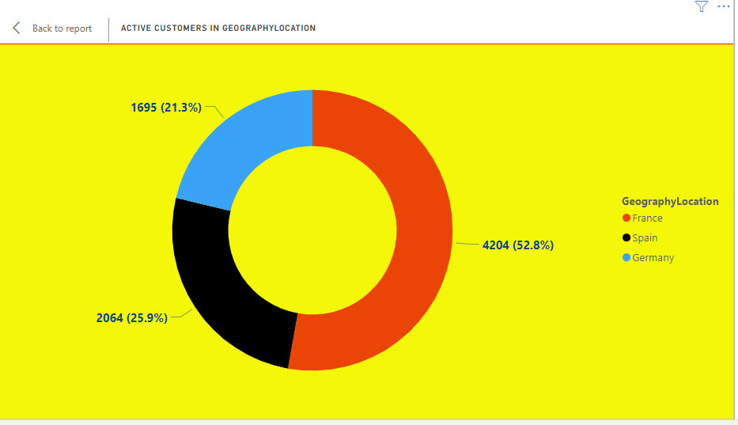

**Location: -**The graph is present in the power bi file in page Geographic Analysis

The SQL query and its solution are provided in the accompanying SQL file. The result and the query used are detailed below for reference.

Select

c.Geography AS Location,

AVG(c.EstimatedSalary) AS AverageSalary,

SUM(CASE WHEN b.ActiveCustomer = 'Active Member' THEN 1 ELSE 0 END) AS ActiveAccounts,

SUM(CASE WHEN b.ExitCustomer = 'Exit' THEN 1 ELSE 0 END) AS ChurnedCustomers

From bankchurn b

JOIN customerinfo c ON b.customerID = c.customerID

Group by Location;

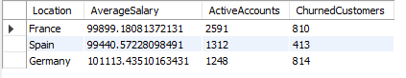

1. Risk Management Assessment: Based on customer profiles, which demographic segments appear to pose the highest financial risk to the bank, and why?

Ans: - Based on the provided bar chart categorizing customers by credit score and salary segment, we can evaluate the financial risk posed by different demographic segments to the bank.

Credit Score Category and Salary Segment Analysis:

* Fair Credit Score Category:
  + High Salary: 826 customers
  + Medium Salary: 846 customers
  + Low Salary: 1659 customers
  + Total Customers: 3331
* Good Credit Score Category:
  + High Salary: 628 customers
  + Medium Salary: 574 customers
  + Low Salary: 1226 customers
  + Total Customers: 2428
* Poor Credit Score Category:
  + High Salary: 610 customers
  + Medium Salary: 552 customers
  + Low Salary: 1200 customers
  + Total Customers: 2362
* Very Good Credit Score Category:
  + High Salary: 321 customers
  + Medium Salary: 305 customers
  + Low Salary: 598 customers
  + Total Customers: 1224
* Excellent Credit Score Category:
  + High Salary: 152 customers
  + Medium Salary: 176 customers
  + Low Salary: 327 customers
  + Total Customers: 655

Highest Financial Risk Demographics:

* Fair Credit Score Category: This segment has the highest number of customers, especially those with low salaries. With 3331 total customers and 1659 in the low salary group, this category poses a significant financial risk due to lower income and mediocre creditworthiness.
* Poor Credit Score Category: Although slightly smaller than the "Fair" category, this segment poses a higher financial risk due to poor credit scores. Among 2362 customers, 1200 are in the low salary segment, making them particularly vulnerable and potentially riskier.

Risk Insights:

* Low Salary Segment:
  + Predominantly present in both "Fair" and "Poor" credit score categories.
  + Represents the highest count within these categories, indicating that income instability combined with low or mediocre credit scores increases the likelihood of defaults and financial instability.
* Fair and Poor Credit Scores:
  + Customers in these categories are more likely to pose financial risks compared to those with very good or excellent credit scores. The combination of fair or poor credit scores with low salaries significantly heightens the risk.

Conclusion:

The demographic segment posing the highest financial risk to the bank comprises low salary individuals with fair or poor credit scores. These customers form the largest groups within their respective credit score categories and present higher risk due to lower financial stability and credit reliability. Effective risk management strategies should focus on closely monitoring and supporting these segments to mitigate potential financial losses.

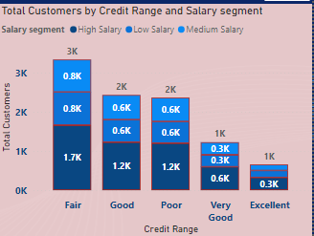

**Location: -**The graph is present in the power bi file in page Additional Analysis

The SQL query and its solution are provided in the accompanying SQL file. The result and the query used are detailed below for reference.

Select c.Geography,

AVG(b.CreditScore) AS AverageCreditScore,

AVG(c.Age) AS AverageAge, COUNT(c.CustomerID) AS CustomerCount

From CustomerINFO c

JOIN Bankchurn b ON

c.CustomerID = b.CustomerID

Group by Geography;

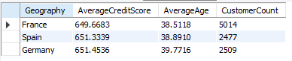

1. Customer Tenure Value Forecast: How would you use the available data to model and predict the lifetime (tenure) value in the bank of different customer segments?

Ans: - The provided visualization illustrates the average tenure of customers, segmented by their balance and salary levels. Each bar represents a specific segment, highlighting the interplay between account balance, salary, and customer tenure. Understanding these relationships is crucial for the bank to develop strategies aimed at increasing customer retention and lifetime value.

Key Insights

1. Medium Balance, High Salary Customers (4.97 years):

* This segment has the highest average tenure, suggesting that customers with medium balances and high salaries tend to stay with the bank longer.
* Possible reasons for higher tenure might include financial stability, potential for future growth, and satisfaction with the bank’s offerings.
* The bank should focus on providing tailored services and perks to maintain and enhance loyalty among these customers.

2. High Balance, Low Salary & Low Balance, Medium Salary Customers (4.91 years):

* Both segments show a similar average tenure, indicating that both high balance with low salary and low balance with medium salary customers have a relatively stable relationship with the bank.
* The high balance, low salary group might consist of individuals who prioritize saving despite lower income, while the low balance, medium salary group might include those who are still building their financial portfolios.
* Customized financial products and advisory services could help in maintaining and potentially increasing the tenure for these segments.

3. Low Balance, High Salary Customers (4.88 years):

* This group has a slightly lower average tenure compared to the top segments.
* High salary customers with low balances might be younger professionals or individuals with significant expenditures.
* The bank can engage this segment with personalized savings plans, investment opportunities, and financial planning services to encourage longer tenure.

4. High Balance, High Salary Customers (4.86 years):

* Surprisingly, this segment does not have the highest tenure despite their high earning and saving potential.
* This could indicate that high balance, high salary customers are more discerning and might switch banks for better services or interest rates.
* Enhancing premium services, loyalty programs, and exclusive offers could help in retaining this high-value segment.

5. High Balance, Medium Salary Customers (4.83 years):

* With an average tenure slightly lower than the high balance, high salary group, these customers also present an opportunity for retention through targeted services.
* Offering mid-tier premium services and personalized financial advice can help in boosting their loyalty.

6. Low Balance, Low Salary Customers (4.80 years):

* This segment, despite their lower financial capacity, shows a reasonable tenure.
* These customers may benefit from financial education programs, basic savings plans, and low-cost financial products to improve their financial health and loyalty.

7. Medium Balance, Low Salary Customers (4.67 years):

* Customers with medium balances and low salaries have a relatively shorter tenure.
* This might be due to financial instability or the search for better opportunities elsewhere.
* Providing support through budgeting tools, financial literacy initiatives, and community banking services could help in improving retention.

8. Medium Balance, Medium Salary Customers (4.57 years):

* This segment has the lowest average tenure among the provided categories.
* Medium balance and medium salary customers might feel that their needs are not fully met.
* Developing mid-range financial products and personalized customer service can address their specific needs and increase their tenure.

Recommendations

1. Personalized Financial Products: Tailor products and services to the specific needs of each segment, especially for high-potential groups like high salary customers.

2. Loyalty Programs: Implement and enhance loyalty programs that reward long-term customers and incentivize them to maintain their relationship with the bank.

3. Financial Education: Offer financial literacy programs to help customers, especially those in lower income segments, manage their finances better and see more value in staying with the bank.

4. Customer Engagement: Regularly engage with customers through personalized communication, check-ins, and feedback mechanisms to understand their needs and preferences.

Conclusion

The analysis of customer tenure across different segments reveals significant insights into how balance and salary influence customer retention. By focusing on tailored strategies and personalized services, the bank can effectively increase the lifetime value of its customers and foster long-term relationships.

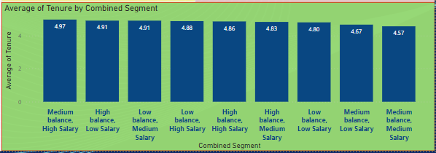

**Location: -**The graph is present in the power bi file in page Additional Analysis

The answer is provided in the SQL file. The code used and the result are given below for reference:

Select

c.Geography,

AVG(b.Tenure) AS AverageTenure,

AVG(b.Balance) AS AverageAccountBalance

From customerinfo c

JOIN bankchurn b ON

c.customerID = b.customerID

Group by Geography;

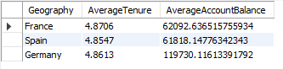

1. Marketing Campaign Effectiveness: How could you assess the impact of marketing campaigns on customer retention and acquisition within the dataset? What extra information would you need to solve this?

Ans: - To evaluate how marketing campaigns affect customer retention and acquisition, follow this structured approach combining data analysis and statistical techniques:

1. Define Key Metrics:
   * Retention: Use metrics like customer churn rate and retention rate.
   * Acquisition: Use metrics such as new customer acquisition rate and customer acquisition cost (CAC).
2. Segment the Data:
   * Organize data by different marketing campaigns to analyze the effects of each campaign individually.
3. Calculate Metrics:
   * Compute the defined metrics for each campaign segment over various time periods (e.g., monthly, quarterly, annually) to observe the influence of each campaign on customer retention and acquisition over time.
4. Compare Campaign Performance:
   * Compare metrics across different campaigns to determine which ones are most effective in retaining and acquiring customers.
5. Conduct Statistical Analysis:
   * Use statistical tests like t-tests or ANOVA to assess whether the differences in metrics between campaigns are statistically significant.
6. Gather Additional Information:
   * Customer Demographics: Analyze demographic data to see if certain groups respond better to specific campaigns.
   * Campaign Details: Review specifics of each campaign, including duration, channels used, and messaging.
   * Competitor Data: Consider competitor activities to understand the competitive landscape.
   * External Factors: Account for external influences like economic conditions, seasonality, or industry trends that might impact customer behavior.

By following this approach and collecting the necessary information, you can effectively evaluate the impact of marketing campaigns on customer retention and acquisition within your dataset.

1. Customer Exit Reasons Exploration: Can you identify common characteristics or trends among customers who have exited that could explain their reasons for leaving?

Ans: - Relationship Between Credit Score Categories and Churn Rate

In the initial chart, we observe distinct churn rates associated with different credit score categories:

* Poor: Approximately 22%
* Very Good: Approximately 20%
* Fair: Approximately 19%
* Excellent: Approximately 18%
* Good: Approximately 17%

Analysis:

Customers with poor credit scores demonstrate the highest churn rates, contrasting with those possessing good to excellent credit scores, who exhibit comparatively lower churn rates. This trend suggests that individuals with poorer financial standing (as indicated by their credit scores) may be more inclined to discontinue their services, possibly influenced by financial instability or dissatisfaction with the provided services.

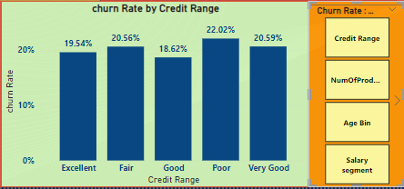

**Location: -**The graph is present in the power bi file in page Additional Analysis 2 under Churn Rate 2 field parameter

**--Salary Segment vs. Churn Rate**

In the second chart, the churn rates by salary segment are:

* High Salary: ~21%
* Low Salary: ~20%
* Medium Salary: ~20%

Analysis:

Churn rates are relatively uniform across different salary segments, indicating that salary alone may not be a significant predictor of customer churn. This suggests that other factors, such as service quality or personal financial management, might play a more substantial role in influencing the decision to leave.

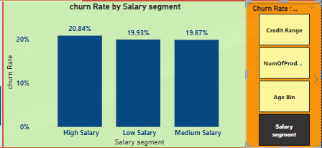

**Location: -**The graph is present in the power bi file in page Additional Analysis 2 under Churn Rate 2 field parameter.

**--Age Groups vs. Churn Rate**

In the third chart, the churn rates by age group are:

* Middle-aged: ~38%
* Old: ~25%
* Adult: ~10%

Analysis:

Middle-aged customers exhibit the highest churn rates, followed by older customers. Adults have the lowest churn rates. This pattern suggests that middle-aged customers might face more financial pressures or have higher service expectations, resulting in higher churn rates. Adults, likely younger customers, appear to be more satisfied or less inclined to switch providers.

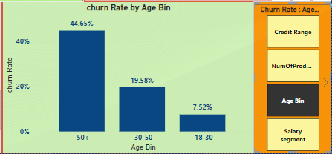

**Location: -**The graph is present in the power bi file in page Additional Analysis 2 under Churn Rate 2 field parameter.

**--Number of Products vs. Churn Rate**

The data for product count vs. churn rate shows:

* 1 Product: 27.71%
* 2 Products: 7.58%
* 3 Products: 82.71%
* 4 Products: 100%

Analysis:

Customers with only one product have a moderate churn rate, which drops significantly for those with two products. However, churn rates rise dramatically for customers with three or four products. This sharp increase suggests that customers with multiple products may feel overwhelmed or dissatisfied with the service complexity or costs, leading to higher churn rates.

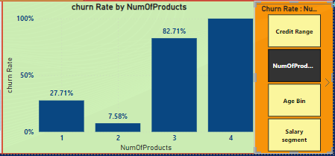

**Location: -**The graph is present in the power bi file in page Additional Analysis 2 under Churn Rate 2 field parameter.

--Credit Card Category vs. Churn Rate

The data comparing churn rates between credit card holders and non-credit card holders shows:

* Credit Card Holders: 20.81%
* Non-Credit Card Holders: 20.18%

Analysis:

The minimal difference in churn rates between credit card holders and non-credit card holders suggests that owning a credit card does not significantly impact the likelihood of customer churn. Thus, credit card ownership is not a strong predictor of customer exit behaviour.

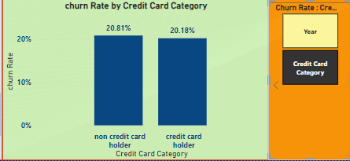

**Location: -**The graph is present in the power bi file in page Additional Analysis 2 under Churn Rate 2 field parameter.

1. Are 'Tenure', 'NumOfProducts', 'IsActiveMember', and 'EstimatedSalary' important for predicting if a customer will leave the bank?

Ans: - This analysis examines whether tenure, number of products held, active membership status, and estimated salary can predict customer churn. We created four charts to visualize trends in these factors for exiting and retaining customers.

Number of Products Held (NumOfProducts)

The first chart, a stacked bar chart, displays the number of customers (y-axis) against the number of products they hold (x-axis). Blue bars represent exiting customers, while orange bars represent those who remain. The chart reveals no clear pattern between the number of products held and churn likelihood. For instance, customers with 1 or 3 products are more likely to exit, whereas those with 2 or 4 products tend to stay. This suggests that the number of products alone is not a strong predictor of churn but may be significant when combined with other factors.

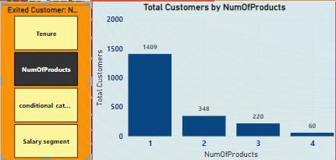

**Location: -**The graph is present in the power bi file in page Additional Analysis 2 under Exited Customer field parameter.

Tenure

The second chart focuses on tenure, displaying the number of customers (y-axis) against categorized tenure groups (x-axis). This stacked bar chart reveals that customers with shorter tenures (0-12 months, 13-24 months) are more likely to churn compared to those with longer tenures (37-48 months, 49+ months). This indicates that tenure is a significant factor in predicting customer churn, with newer customers being more likely to leave.

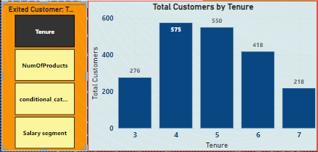

**Location: -**The graph is present in the power bi file in page Additional Analysis 2 under Exited Customer field parameter.

**--Active Member Status (IsActiveMember)**

The third chart examines the relationship between active member status and customer churn. The x-axis represents whether a customer is an active member (Yes/No), and the y-axis shows the number of customers. When focusing on exiting customers (Exit), the chart shows that only inactive members (IsActiveMember = No) are present. This suggests that active members (IsActiveMember = Yes) are significantly less likely to churn, making active membership status a strong predictor of customer retention. The clear absence of active members among those who exit highlights the importance of engaging customers to maintain their active status as a strategy to reduce churn.

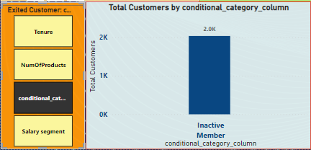

**Location: -**The graph is present in the power bi file in page Additional Analysis 2 under Exited Customer field parameter.

**Estimated Salary**

The fourth chart explores the impact of estimated salary on customer churn. This bar chart segments customers by salary ranges, showing counts for both those who exited (Exit) and those who remained (Retain). The analysis reveals that customers in lower salary segments are more likely to churn compared to those in higher salary segments. This suggests that estimated salary is a significant predictor of churn, with lower salary customers being more prone to leaving the bank. Potential reasons for this trend could include higher price sensitivity, lower satisfaction, or a greater risk of service interruption due to financial instability.

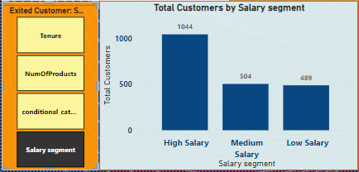

**Location: -**The graph is present in the power bi file in page Additional Analysis 2 under Exited Customer field parameter.

In summary, the analysis of these four factors—number of products held, tenure, active membership status, and estimated salary—provides valuable insights into customer churn. While tenure and estimated salary demonstrate clearer trends, factors like the number of products held and active membership status might require consideration alongside other variables to improve predictive accuracy.

1. Utilize SQL queries to segment customers based on demographics and account details.

Ans: - The answer is provided in the SQL file. The code used and the result are given below for reference:

--------- Segmenting by Geography

Select

Geography,

COUNT(CustomerID) AS CustomerCount

From CustomerInfo

Group by Geography

Order by CustomerCount DESC;

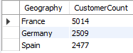

----------- Segmenting by Age Group

Select

Case

When Age Between 18 AND 30 Then '18-30'

When Age Between 31 AND 50 Then '31-50'

Else '50+'

END AS AgeGroup,

COUNT(CustomerID) AS CustomerCount

From CustomerInfo

Group by AgeGroup;

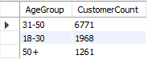

------------ Segmenting by Number of Products

Select

NumofProducts,

COUNT(CustomerID) AS CustomersCount

From Bankchurn

Group by NumofProducts

Order by CustomersCount DESC;

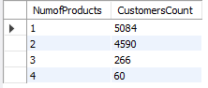

-----------Segmenting by Credit Score

SELECT CASE

WHEN CreditScore BETWEEN 800 AND 850 THEN 'Excellent'

WHEN CreditScore BETWEEN 740 AND 799 THEN 'Very Good'

WHEN CreditScore BETWEEN 670 AND 739 THEN 'Good'

WHEN CreditScore BETWEEN 580 AND 669 THEN 'Fair'

WHEN CreditScore BETWEEN 300 AND 579 THEN 'Poor'

ELSE 'Unknown'END AS CreditScoreCaregory, COUNT(*) AS NumChurnedCustomers,

DENSE_RANK() OVER (ORDER BY COUNT(*) DESC) AS CreditRank

FROM Bankchurn

WHERE ExitCustomer = 'Exit'

GROUP BY CreditScoreCaregory

ORDER BY CreditRank;

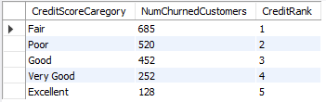

1. How can we create a conditional formatting setup to visually highlight customers at risk of churn and to evaluate the impact of credit card rewards on customer retention?

Ans: - To visually highlight customers at risk of churn and evaluate the impact of credit card rewards on customer retention, follow these steps based on the provided filter window chart:

1. Identify the Churn Criteria: Define the criteria to identify customers at risk of churn, considering factors such as:
   * Customers with a low number of products purchased (NumOfProducts).
   * Customers in low salary segments.
   * Customers who have recently exited (Exit Category = "Retain").
2. Specific Conditions Applied:
   * Credit score is either "Poor" or "Fair".
   * Product count is less than or equal to 2.
   * Salary segment is "Low Salary".
   * Exit category is "Retain".
3. Apply Conditional Formatting Based on Churn Criteria: Implement a conditional formatting rule to highlight cells meeting the churn criteria. Use different background colors or fonts to make these cells visually distinct.
4. Filter by Credit Card Ownership: Create a filter for the "HasCrCard" field to segment customers by whether they have a credit card or not.
5. Evaluate Churn Rate by Credit Card Ownership: Analyze the churn rate (percentage of customers who exited) for customers with and without credit cards. Compare the number of exited customers (where Exit Category = "Exit") to the total number of customers.

Conclusion: By setting up conditional formatting to highlight at-risk customers, you can visually identify those on the verge of churning, allowing for targeted interventions such as personalized offers or loyalty rewards to retain them. Additionally, by filtering and analyzing the impact of credit card ownership on churn rates, you can determine if credit card rewards effectively retain customers. If customers with credit cards show lower churn rates, it indicates that credit card rewards are a successful retention strategy. Conversely, if there is no significant difference, it may suggest the need to reassess the reward program's effectiveness. 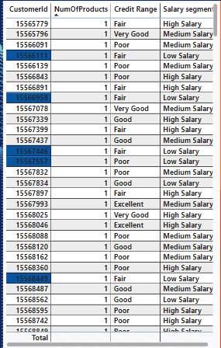

**Location: -**The graph is present in the power bi file in page Additional Analysis

The answer is provided in the SQL file. The code used and the result are given below for reference:

Select

CustomerID,

Case

When Tenure < 4 AND NumofProducts = 1 Then 'High'

When Tenure >= 4 AND NumofProducts > 1 Then 'Low'

ELSE 'Medium'

END AS ChurnRisk

From Bankchurn;

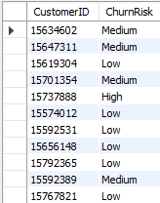

1. What is the current churn rate per year and overall as well in the bank? Can you suggest some insights to the bank about which kind of customers are more likely to churn and what different strategies can be used to decrease the churn rate?

Ans: - This analysis examines customer churn rates to identify segments most at risk and proposes strategies to decrease churn and enhance customer retention.

Churn Rate Analysis:

* Overall Churn Rate: 20.37%
* Year-on-Year Churn Rates:
  + 2016: 19.27% (lowest)
  + 2017: 22.35% (highest)
  + 2018: 20.21%
  + 2019: 19.86%

Customer Segments Prone to Churn:

The data highlights specific customer segments with a higher likelihood of churn:

* Single Product Users: These customers might not perceive enough value compared to competitors offering a broader range of services.
* Credit Card Holders: Potential reasons for churn include:
  + Insufficient credit limits
  + Lack of appealing rewards programs
  + High fees
* Tenure of 4-5 Years: Customers in this group might be losing introductory offers or discounts, making them more susceptible to better offers from competitors.
* High Salary Earners: These customers may have more options and might switch for slightly better rates or benefits.

Recommendations to Reduce Churn:

* Targeted Product Bundles: Develop and offer bundles tailored to specific customer needs, especially for those using only one product, to highlight additional benefits and cost savings.
* Enhanced Credit Card Rewards:
  + Increase credit limits based on customer history and creditworthiness.
  + Offer rewards programs that match spending habits (e.g., travel rewards, cash back for specific categories).
  + Consider reducing or eliminating annual fees for high-value customers.
* Retention Offers for Existing Customers: Reach out to customers nearing the end of introductory offers with personalized retention deals, such as extending introductory rates or offering discounts on other products or services.
* Customer Satisfaction Surveys: Regularly conduct surveys to understand the reasons behind customer churn, identifying areas for improvement and tailoring retention strategies accordingly.
* Relationship Management for High-Value Customers: Assign dedicated relationship managers to high-value customers to provide personalized service, address specific needs, and offer exclusive benefits.

Conclusion:

By identifying at-risk segments and implementing targeted retention strategies, the bank can reduce churn rates and enhance overall customer satisfaction and loyalty.



**Location: -**The graph is present in the power bi file in page Customer Analysis

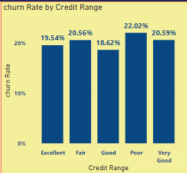

**Location: -**The graph is present in the power bi file in page Additional Analysis

The answer is provided in the SQL file. The code used and the result are given below for reference:

------------ Churn Rate Per Year

Select

YEAR(BankDOJ) AS JoiningYear,

SUM(Exited) AS ChurnedCustomers,

COUNT(b.CustomerID) AS TotalCustoemrs,

SUM(Exited) / COUNT(b.CustomerID) AS ChurnRate

From Bankchurn b

JOIN CustomerInfo c ON

b.customerID = c.customerID

Group by JoiningYear

Order by ChurnRate;

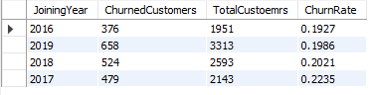

-------------- Overall Churn Rate

Select

SUM(Exited) AS TotalChurnedCustomers,

COUNT(CustomerID) AS TotalCustomers,

SUM(Exited) / COUNT(CustomerID) AS OverallChurnRate

From Bankchurn;



1. Create a dashboard incorporating all the KPIs and visualization-related metrics. Use a slicer in order to assist in selection in the dashboard.

Ans: - I've developed a five-page dashboard covering various analytical aspects:

* Page 1: Customer Analysis
* Page 2: Demographics
* Page 3: Geographic Analysis
* Page 4: Additional Analysis
* Page 5: Additional Analysis 2

Each page includes interactive slicers for Exit Category, Year, Churn Rate, and Exited Customer. Furthermore, field parameters for essential metrics like churn rate and exited customers have been integrated, facilitating dynamic and detailed insights.  
  
Following are my dashboard pages

**Customer Analysis**

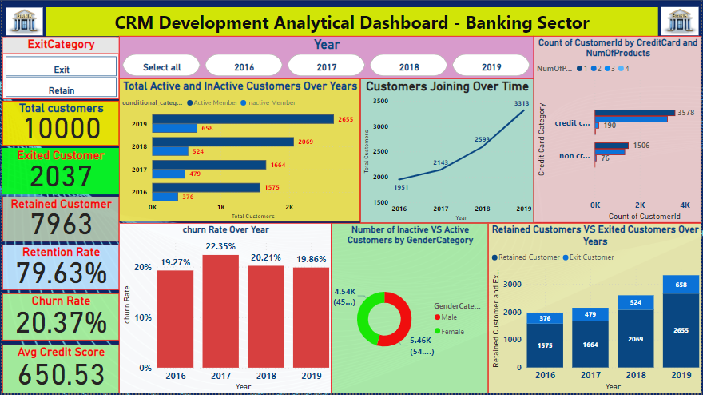

**Demographics**

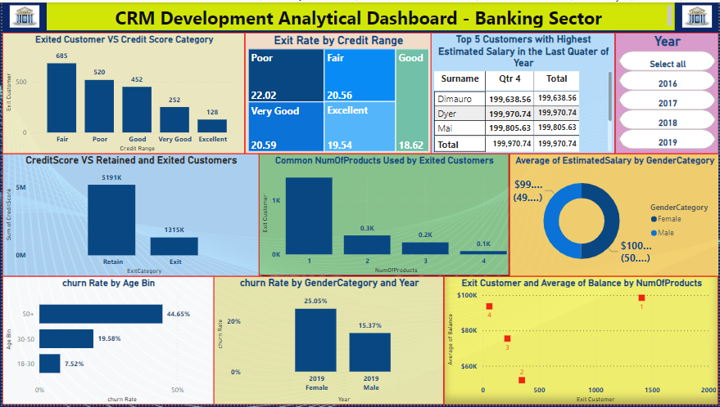

**Geographic Analysis**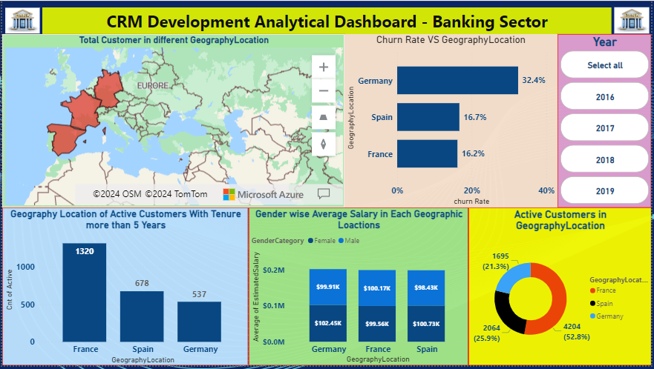

**Additional Analysis**

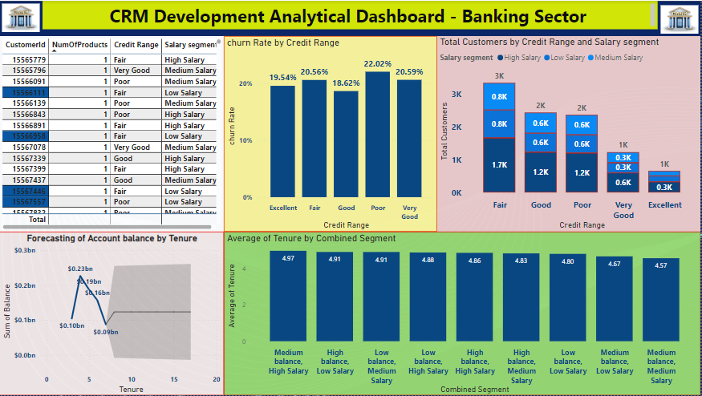

**Additional Analysis 2**

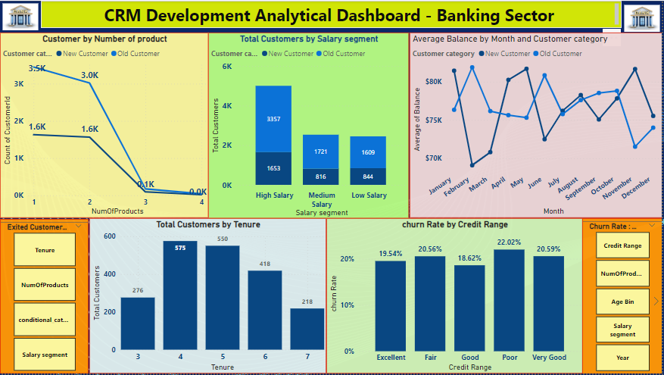

1. How would you approach this problem, if the objective and subjective questions weren't given?

Ans: - Even if there aren't explicit questions provided, we can still tackle a problem effectively by following a structured approach. Here's how:

1. Develop Hypotheses:
   * Start by forming assumptions about the data or issue at hand. These assumptions can come from your knowledge of the field, industry standards, or initial observations of the data.
2. Formulate Questions:
   * Use your hypotheses to create specific questions that the available data can answer. These questions will guide your analysis and help validate or refine your initial assumptions.
   * For example, in a customer churn analysis:
     + Are there any demographic trends (like age or income) associated with customer churn?
     + Does factors like account balance or the number of products a customer holds affect their likelihood of churning?
     + How does customer activity, such as transactions or logins, relate to churn rates?
   * In a marketing campaign analysis:
     + Which marketing channels, such as email or social media, are most effective at reaching our target audience?
     + Is there a relationship between the amount spent on advertising and the performance of our campaigns?
     + How does the content of our campaigns impact customer engagement and conversion rates?
3. Explore and Analyze Data:
   * Use various techniques, like data visualization and statistical analysis, to address the questions you've formulated. This step involves examining the data closely to find insights that can help answer your questions.
4. Draw Insights and Make Recommendations:
   * Based on your analysis findings, draw conclusions that can inform decision-making. These insights could relate to customer behavior, effective marketing strategies, potential product improvements, or other relevant aspects of the problem.
5. In the “Bank_Churn” table how can you modify the name of the “HasCrCard” column to “Has_creditcard”?

Ans: - The answer is provided in the SQL file. The code used and the result are given below for reference:

Alter Table Bankchurn

Rename Column HasCreditCard to Has_creditcard;

Select * from bankchurn;

